COPY and PASTE Rosters from Infinite Campus
into the
ODE PE Data Spreadsheets

- Sign-in to Infinite Campus
- Open up Excel ODE Data Spreadsheet
- Save Excel File as School name, year and grade level, i.e., Beechcroft_2019_PEII
- Ensure that you are in Standard 1A and place your curser in the first block under student name. This process will copy names automatically to all sheets on the document.
- Click on Instruction Tab, top right:


- Click on Menu Top Left:
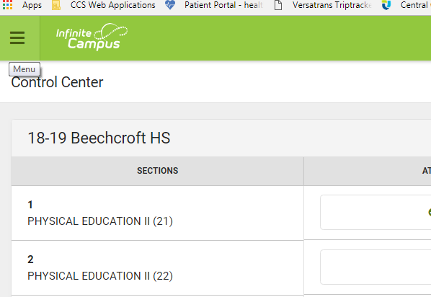

- Click on Reports:

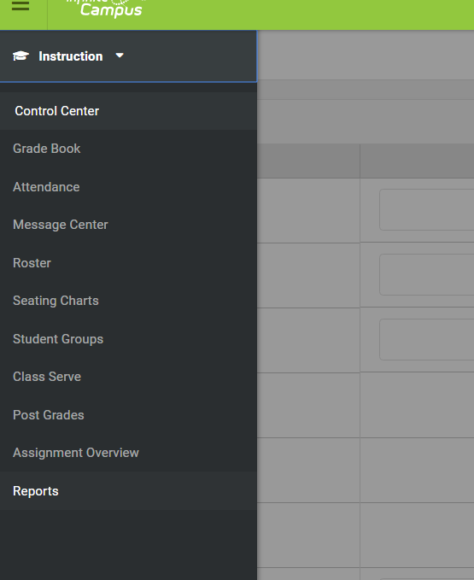

- Click on Roster/Blank Spreadsheet:
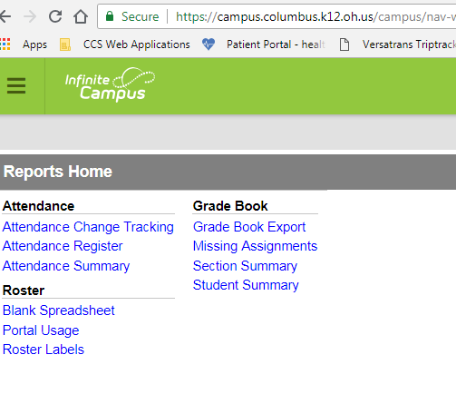

- Select which class you want to create report for:
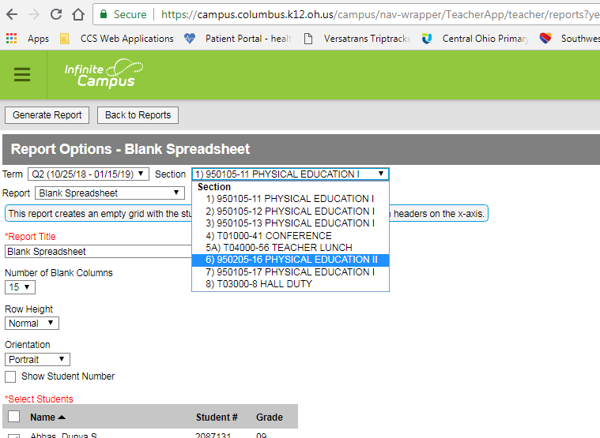

- Click on Generate Report box:
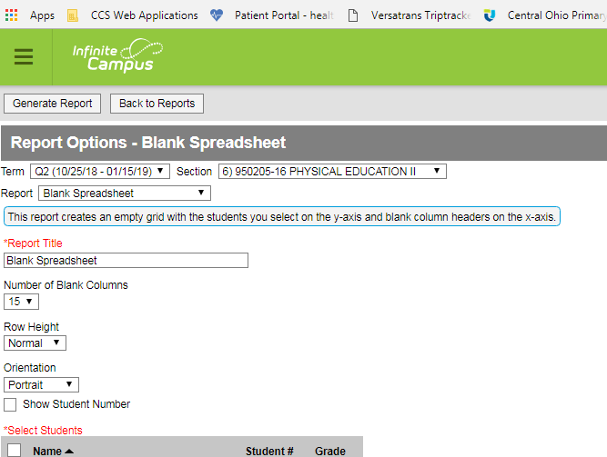
- A Blank spreadsheet will appear with the roster of your class that you selected:
- Copy the roster by highlighting names.
  - The grade level will appear on the spreadsheet as well.
  - If a student has a long name you will need to highlight down to the first row of the long name and copy. Then paste into spreadsheet. Then repeat for rest of the names on the roster.

- When pasting into the excel spreadsheet, this gets tricky:
  - Paste special:
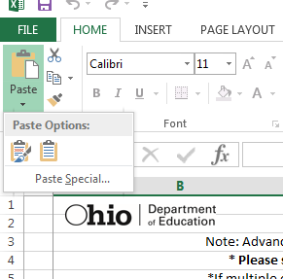
- Another popup will appear and select Text: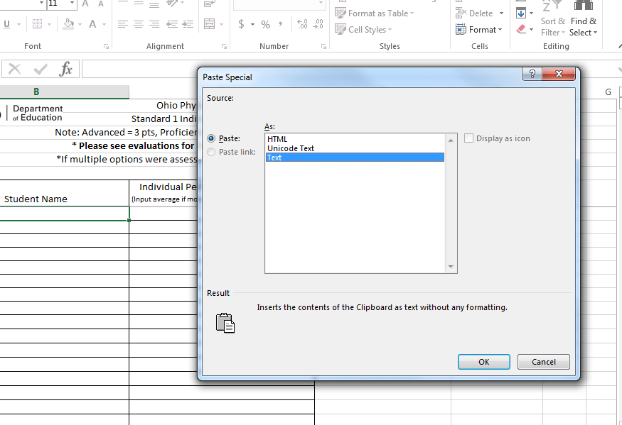

- Continue to repeat until all names are copied and pasted:
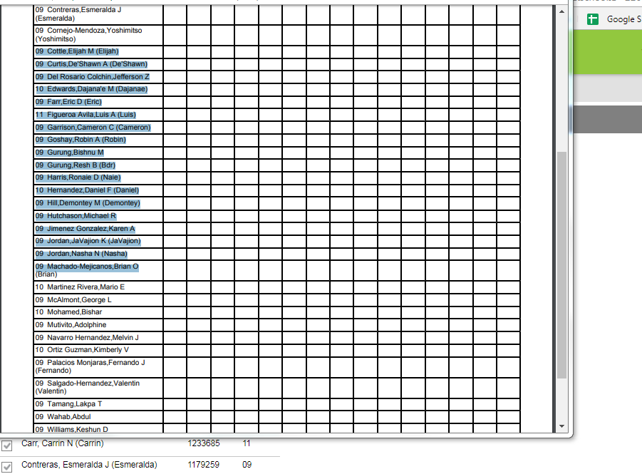
- The last step in the process to copy and paste names is to make sure that you save your document, this can be done on the hard drive that you are using or a portable storage drive.
- The preferred method to send your completed excel ODE PE Spreadsheet is by attaching your document to an email and send to Dcain7245@columbus.k12.oh.us
- If you want to check what your data looks like, go to the last sheet on your excel document, “Data for ODE”.
- If you see that some of your students’ scores didn’t transfer go back to the previous tab, “Student Totals”.
  - If you see that you have any cells that are in this format “#DIV/0!” this means that a cell score was left blank and you can delete this cell so that you have an average score for the student, (I usually perform this function with everyone’s data when submitted to me).
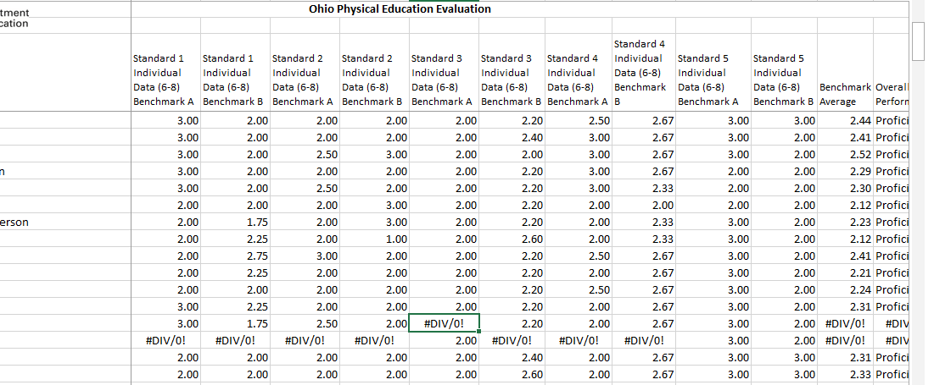
  - Click on “Review”
  - Click on “Unprotect Sheet”
  - Go to cell and click “Delete” Key.
  - This will remove the formula so it will not be added in the average of rest of the cells.
  - Perform this function with all cells that have this format, “#DIV/0!”.
